AM000-Asia-China-Yuan-Bloom And Bird Pattern Bronze

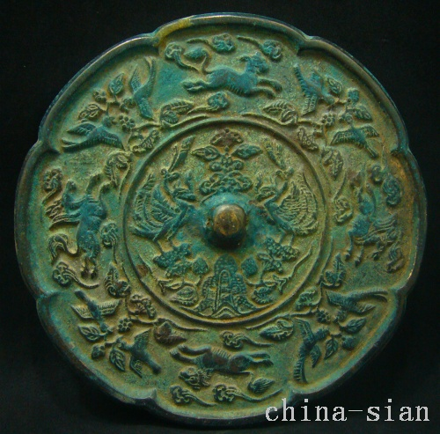

Diameter 141  mm     Deep  4.5  mm